Custom Mapping Extension for WFS Integration

**Table of contents**

Step-by-Step Instructions 3

Step 1 3

Step 2 3

Step 3 4

Step 4 4

Step 5 5

Step 6 6

Step 7 7

**Step-by-Step Instructions**

**Step 1**

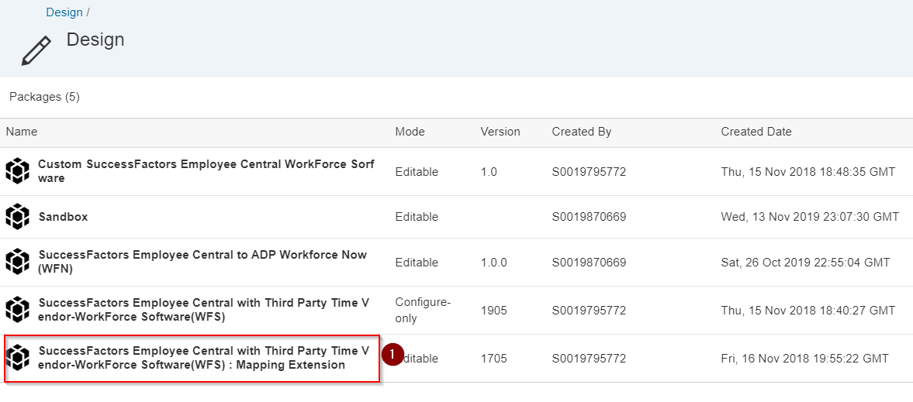

**Step 2**

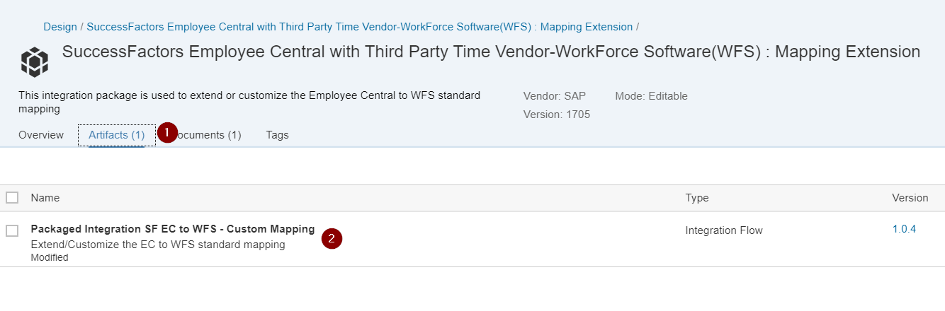

**Step 3**

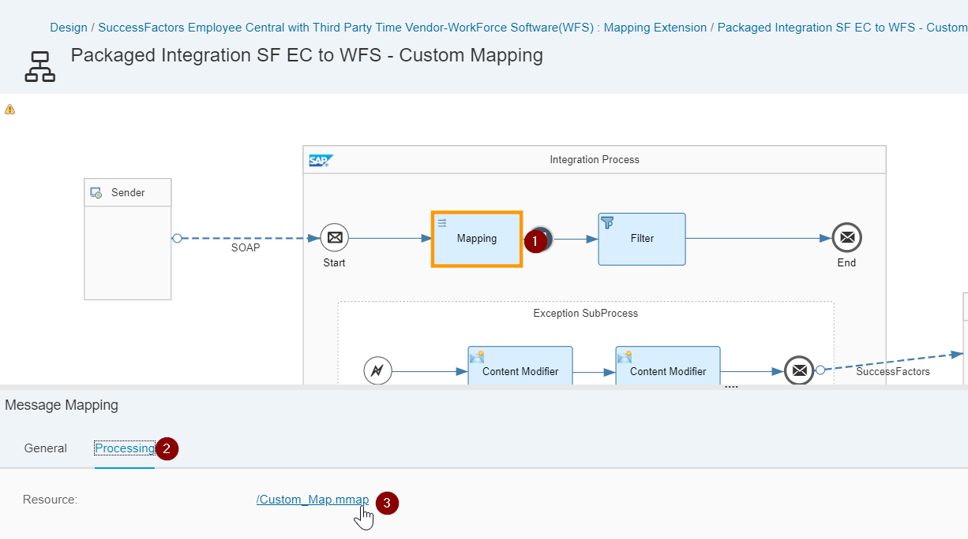

**Step 4**

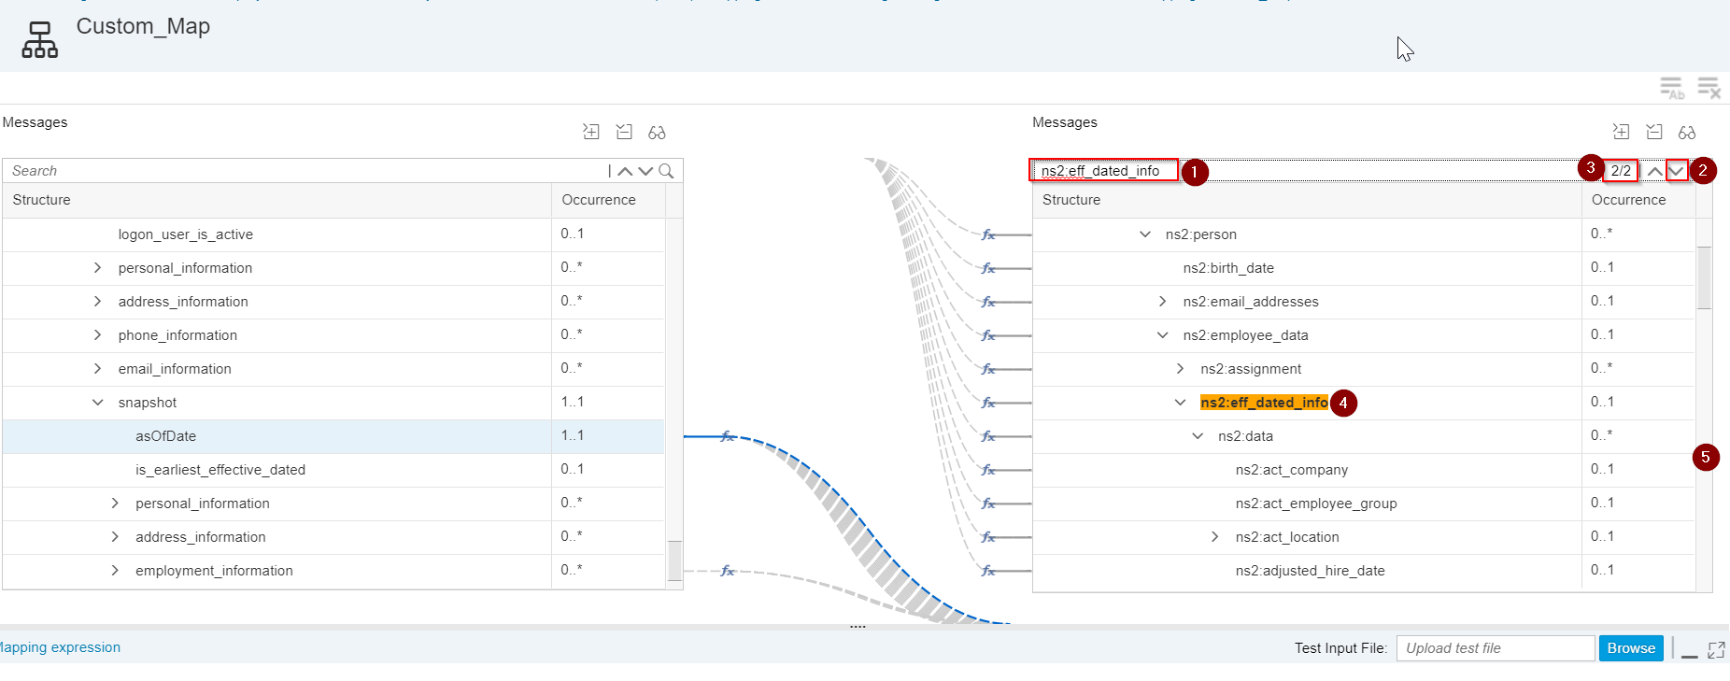

On part 5, scroll down until you see the following:

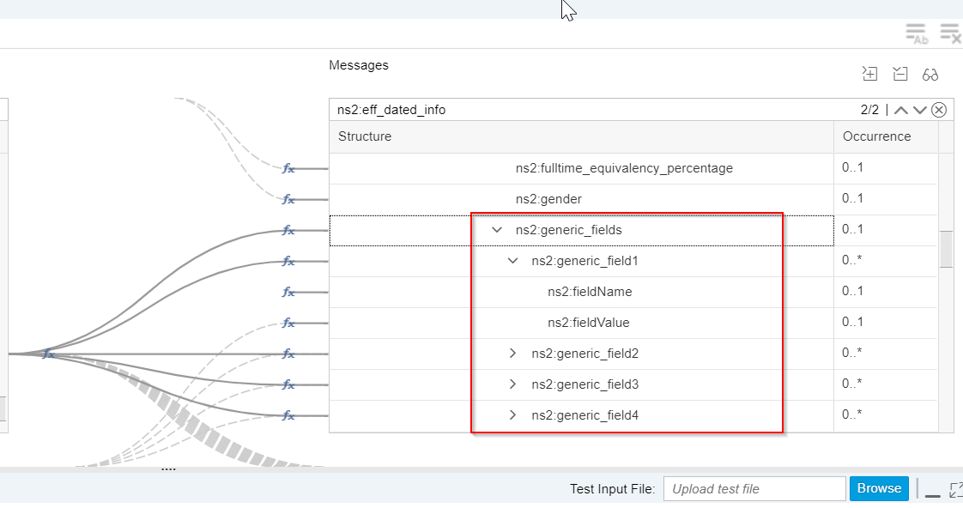

**Step 5**

Map asOfDate to ns2:generic_field17, ns2:generic_field18, etc.

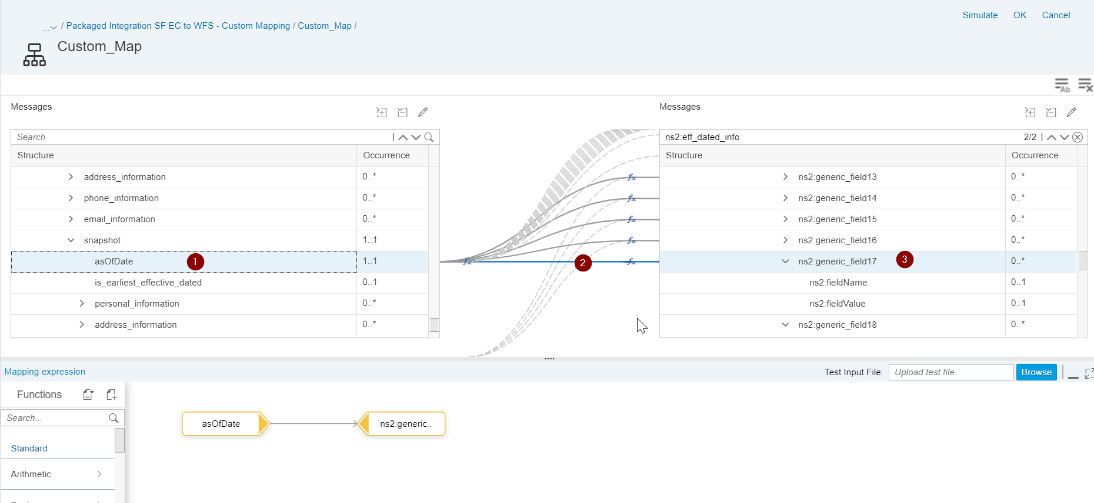

**Step 6**

Set ns2:fieldName to the WFS custom field name.

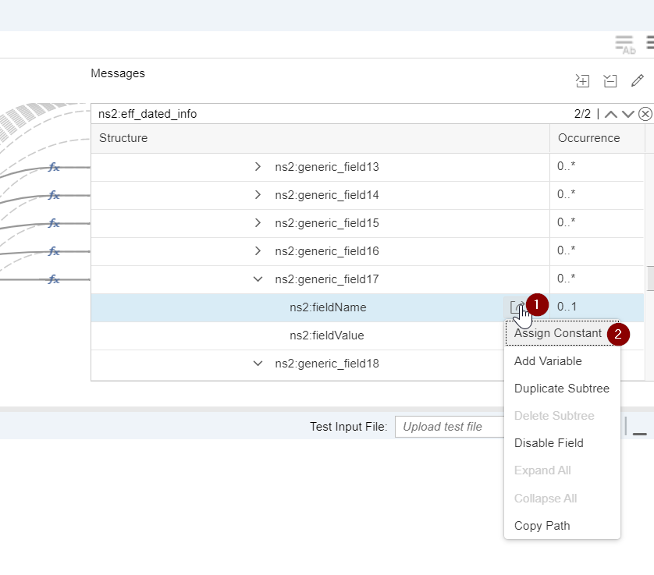

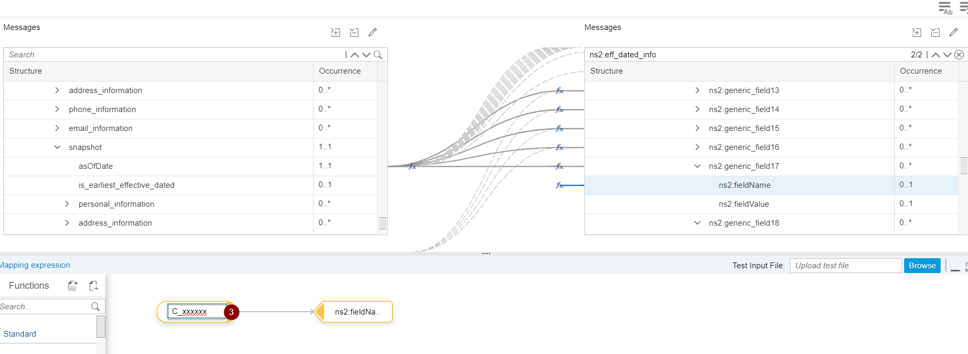

**Step 7**

Map custom value from left side. Below is an example.

